Augmented Reality on Binocular Optical See-Through Displays

General information

The main idea of the project is to create augmented reality. Most of the AR applications these days are with cameras and displays. To enable good AR applications with 3D perception, it is needed to overlay correct 2D positional alignment. In our project, we screen the output image as a stereo image, and each eye gets a different image with the correct alignment.

Implementation

As we learned in the project, the eyes see the same object in different positions due to the distance between the eyes. The positions vary between objects, depending on their distance to the eyes.

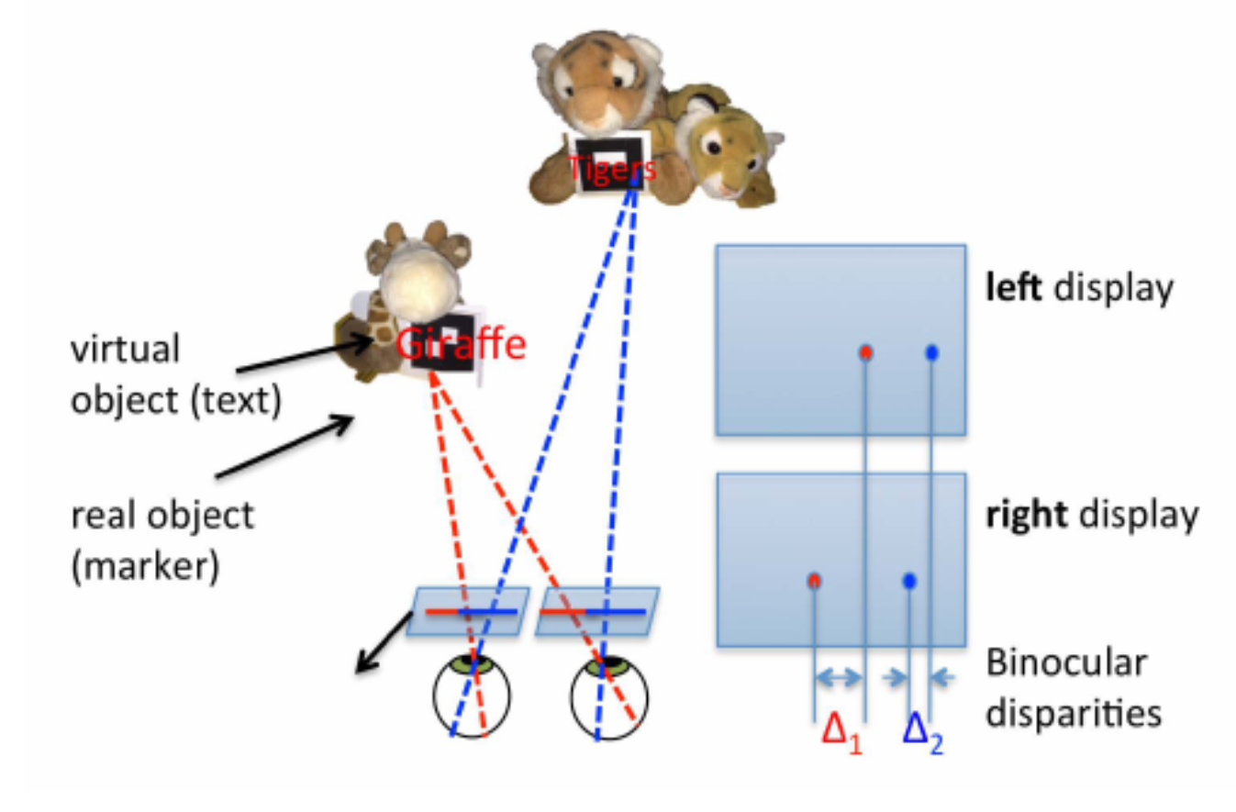

Figure 1: Different offset accordingly to the distance

We can separate the image correction into two parts: GUI & table projection. On the GUI, we had to add an offset to the right image for all the text. The offset is constant, and it gives a perception that the GUI is far enough to read and ease the eye.

Table projection was more important for integrating virtual content into a real scene but easier. We did the corner detection on each image from the stereo image for a distance map, and on the way, we received the accurate projection and position of the table. Therefore, the offset of the content between each image changed accordingly to the distance to the object. (opposite the GUI that was constant).

The last part was to modify the image to fit in a VR headset using a phone as a display. When the display is right on the face, there is a content in the middle and the sides the eyes can’t reach. After removing the dead zones, we helped the eyes by focusing only on the important things.

Assumptions and limitations

The only assumption that we have is the screen display of the phone. Different screen sizes will change our calculation. We chose the constant GUI offset according to our phone setup.

Results

[Reshaped image with GUI offset and table content]

# <https://www.researchgate.net/publication/283117341_Depth-Disparity_Calibration_for_Augmented_Reality_on_Binocular_Optical_See-Through_Displays>

Wu, Wanmin & Tosic, Ivana & Berkner, Kathrin & Balram, Nikhil. (2015). Depth-Disparity Calibration for Augmented Reality on Binocular Optical See-Through Displays. Proceedings of the 6th ACM Multimedia Systems Conference, MMSys 2015. 10.1145/2713168.2713171.